# Service Oriented Development

Module Co-Ordinator: **Dr. Ying Lang**

Team Members:

* Manuel Cantonero B00228318
* Abubacarr Sillah BannerID
* Mario A. Corchero B00228346

Submision Date: XX-XX-2011

# Content

Goals and objectives of the video rental business

Business context diagram for the video store.

Business process model for the high-level video rental process.

Use case diagram for the video store

Scenario diagrams for the “Rent videos” use case.

Class diagram for information to be shared between services.

Service interface diagram for the “Rent videos” service

Activity diagram for defining the control and data flow of the “Rent video” service operation implementation.

An individual report from each group member (about 2 pages) containing a critical assessment of the experience gained on the coursework, e.g.

Project diary

# Goals and objectives of the video rental business

Value Chain:

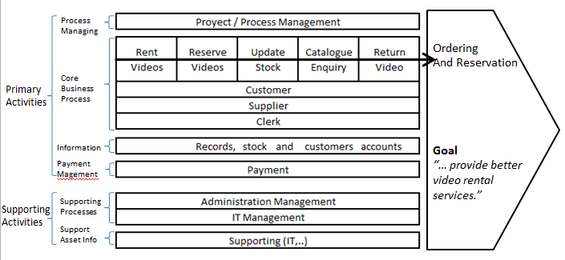

## Business Motivation Model for the Video rental system

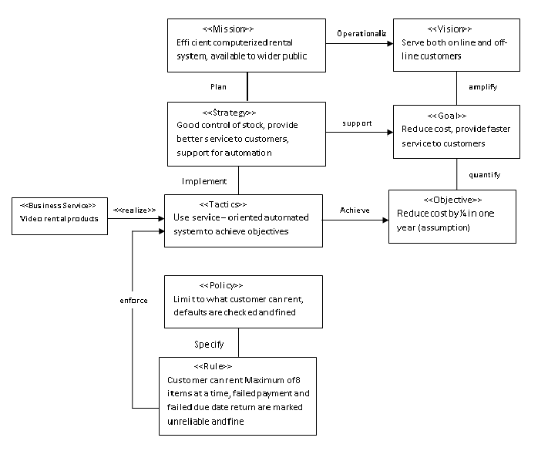

# Business context diagram for the video store.

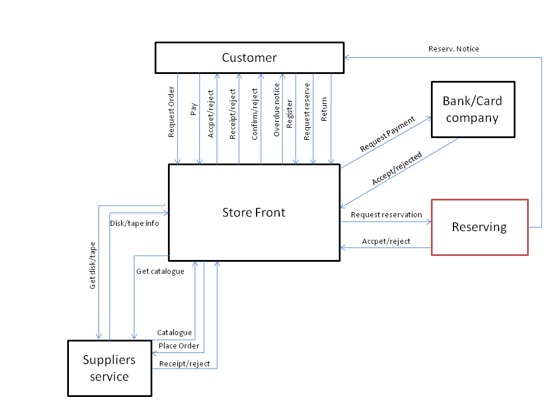

# 

# 

# Business process model for the high-level video rental process.

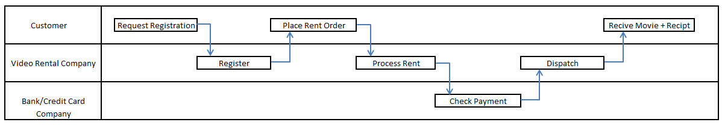

# Use case diagram for the video stock

# Scenario diagrams for the “Rent videos” use case.

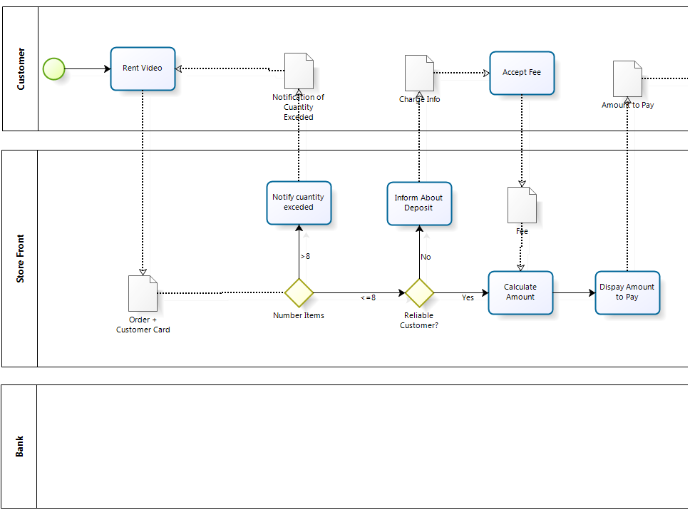

# 

# 

# 

Note:Some arrows couldn’t be represented as control arrows so the tool we used didn’t let us.

# Class diagram for information to be shared between services.

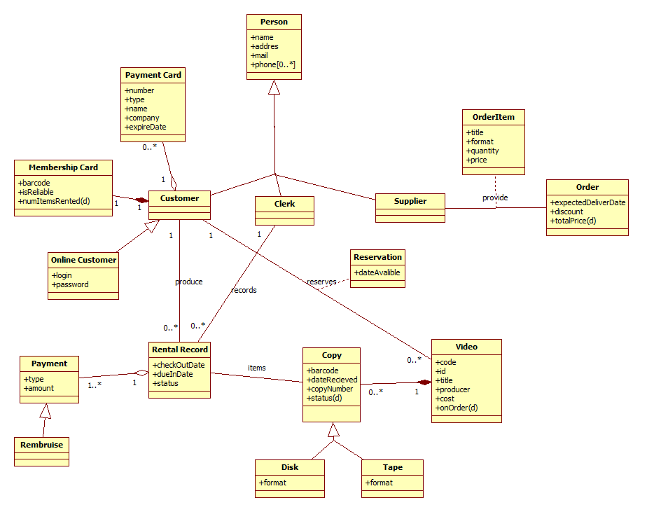

#### Annotations:

* All the attributes tagged with “(d)” means they are derived.
* About disk and tape. We choose generalization instead of an attribute because the format in the two types are different and the system pretends to be scalable, being generalization more adequate for this purpose.
* In the first review, we identify that disk and tape becomes from Video, but it’s more correct to generalize from copy.
* Reimburse arise from the necessity to be differentiated from payment and we choose generalization instead of an attribute because we consider that the second approach is more versatile.

The generalization from customer, clerk and supplier from person will provide higher flexibility and scalability to the system.

# Service interface diagram for the “Rent videos” service

# Activity diagram for defining the control and data flow of the “Rent video” service operation implementation.

# An individual report from each group member (about 2 pages) containing a critical assessment of the experience gained on the coursework, e.g.

# Project diary

|  |  |  |  |  |
| --- | --- | --- | --- | --- |
| Number meeting | Date | Time | Attendance | work |
| Meeting 1 | 18/10/2011 | 10:00-13:00 | Abubacarr Sillah  Mario Corchero  Manuel Cantonero | Start the coursework.  Read the Coursework Specification.  We debated items one and two.  **Item 1:** Goals and objectives -> we find some goals and objectives for the specified system.  **Item 2:** Business context diagram -> Everyone create his own context diagram, we unifying them in a simple one, and a complex one. we will revise them the next meeting. |
| Meeting 2 | 24/10/2011 | 14:00-16:30 | Abubacarr Sillah  Mario Corchero  Manuel Cantonero | • We have discussed concerning issures and needs see Dr. Ying Lang  • Reviewed context diagram  • Business process diagram discussed and produced first version  • Use case diagram discussed and produced high level version |
| Meeting 3 | 01/11/2011 | 09:00-12:00 | Abubacarr Sillah  Mario Corchero  Manuel Cantonero | • We discussed and create the value chain.  • Redraw context diagram with the value chain model.  • Redraw business process model for the high-level rental process (there were a lot of mistakes)  • Reviewed use cases diagram  • First version of Scenario diagram. |
| Meetin 4 | 08/11/2011 | 10:00-12:00 | Abubacarr Sillah  Mario Corchero  Manuel Cantonero | • We finish the Business motivation model.  • Redraw Scenario diagram.  • First Version of the Class diagram. |